STUDENT Joseph Roper

Salford City College | [Company address]

BTEC National 90 Credit Diploma in Creative Media Production

Unit 13: understanding the industry

Table of Contents

This is my first heading 2

This is my subheading 2

Title

# Task 1

### Developer

Game Developers, like in the name develop games or at least the programming part of the game. Game developers have to be great at problem solving, as that is a big part of their job: finding and solving bugs. Developers have to think analytically and know how to efficiently fix bugs and various other issues. They also have to stay up to date on different techniques and programming languages.

<https://www.youtube.com/watch?v=maxfz3ogqfk>

[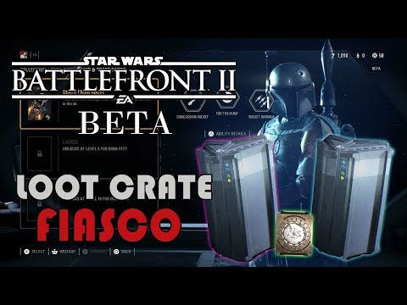](https://www.youtube.com/watch?v=txdY6fzjef8)A developer team I would want to work for is Blizzards for the game Overwatch. Firstly, because I like the look of their offices showing that the company cares about its workers. Secondly, because they really listen to their fans to find bugs and solve them as they have a frequently active discord and Reddit page, where the players of the game can post bugs in the game with a description of how it was caused. Then a developer of the game will look at it and reply for further information to then fix the game. Unlike EA when they will only listen to their fans when there is a massive backlash and the media gets involved for instance what happened with the Battlefront 2 game where they added micro transactions for loot boxes in a £50-pound game. The video above this paragraph explains why this is such a problem.

### Publishers

Publishers are the people who make games available for the public by putting the game in stores and online shops such as Steam and Game. For example, if I make a game on my own I won’t have the resources and connections to get it into stores and if I do it will be really expensive and hard, that is why well known publishers are viewed highly as they can easily get a game out there. However, because publishing a game is hard the publishers take a big cut out of the revenue being made for the game.

A publisher I would want for my game is Devolver Digital as they try and help indie developers with low funds get their game out there for a fair price and also with fair terms. The company has helped publish these fantastic and widely popular games in the past; Titan Souls, Hotline Miami and Broforce. <https://www.devolverdigital.com/games/page/>

[](https://www.pcgamesn.com/devolver-digital-games-being-sold-illegitimately-online)[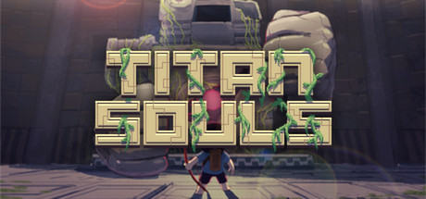](http://store.steampowered.com/app/297130/?l=spanish)

A publisher who I would not want to release my game is Atari because they will try to sneak certain obligations that the developer will have to fulfil into the contract. This happened to CD Project Red when Atari was going to publish The Witcher, as the contract they signed made it so CD Project red had to publish the sequels of the game with Atari and CD Project Red was unaware of this and had to pay Atari to change it. The video below explains my point in more detail. [**https://www.youtube.com/watch?v=EXCP-BI36xc**](https://www.youtube.com/watch?v=EXCP-BI36xc)

[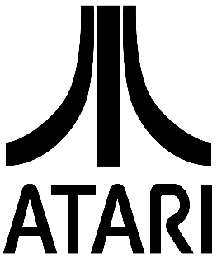](https://en.wikipedia.org/wiki/Atari,_Inc.)[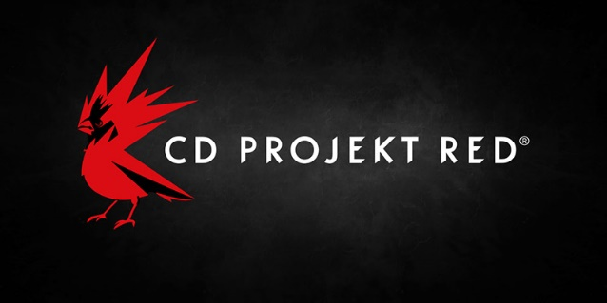](http://en.cdprojektred.com/)[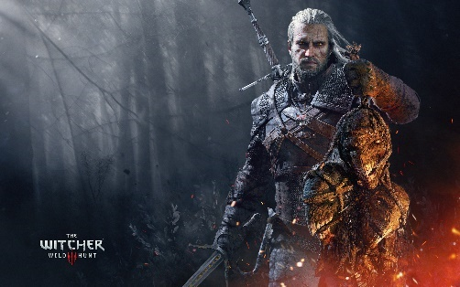](http://thewitcher.com/en/witcher3)

### Console Manufacturers/ First Party Publishers

Console manufacturers are the people/company that will make your favourite gaming systems for example Nintendo with the Nintendo Switch, Sony with the PlayStation 4 and Microsoft with the Xbox One. First party publishers are people who create original game IP has and publish them making it available for the public. First party games are made by big companies and will usually always be exclusive for that company’s system, causing exclusives to widely influence which console someone will buy. For example, if you want to play a Mario or Zelda game, you will have to buy a Nintendo system and if you want to play Spiderman, Persona 5 and the Uncharted series you will have to buy a PlayStation 4.

[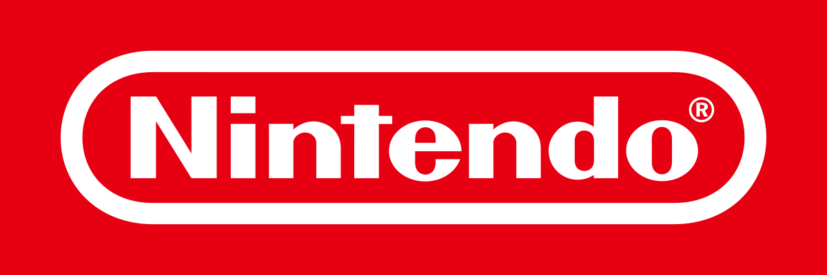](https://en.wikipedia.org/wiki/Nintendo_Australia)[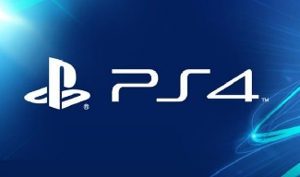](https://www.express.co.uk/entertainment/gaming/910654/PS4-PlayStation-Plus-February-free-game-PSN-Down-Xbox-One-X-Monster-Hunter-World)[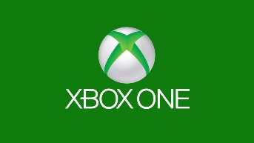](https://www.gamespot.com/articles/xbox-one-weekly-news-roundup-microtransaction-mist/1100-6456992/)

Exclusives are why I would rather work for Nintendo over Microsoft as Nintendo’s whole aspect of gaming is that they will only make a fun game over anything otherwise they scrap the project. Meaning that if I worked for Nintendo I would be developing a game that is fun rather than a game that is solely made to earn money like Microsoft as their main exclusive franchise for the Xbox One is Forza and they make a sequel every year without really improving on the gameplay or making the game fun.

### Distribution and Retail

Distributers are companies that sell games to the public an example of an online distributor is Steam they are widely popular and are known as the number 1 online seller of video games. In addition, an example of a store that sells video games is Game they are popular in the UK but have been slowly closing down their shops because of online sales.

[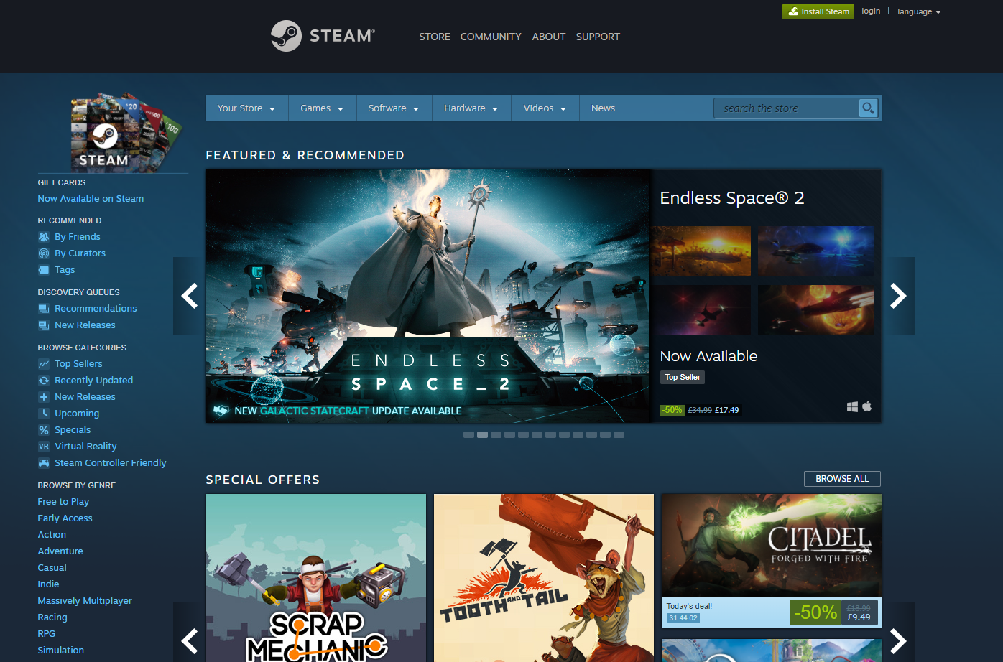](http://store.steampowered.com/) [](http://redhillbelfry.co.uk/stores/books/game/)

As you can see from the graph there has been a slow decline in the distribution of physical copies of games since 2009 until present day while the sales of digital copies of games has steadily gone up over 7 years. Digital sales increasing is a good thing for publishers and developers as they don’t have to spend a lot of money on game boxes and disk costs. However, this is bad as now game retail stores are closing down due to online sales and they now have to outsource into different demographics such as clothing as you can now see if you go into your local game retailer such as “Game”. I think the reason digital copies of games are more popular is because you can buy and download the game from the comfort of your own home without dealing with pesky sales representatives trying to get you to buy more than you need.

[](https://www.statista.com/statistics/190225/digital-and-physical-game-sales-in-the-us-since-2009/)

### Outsourcing Companies

When developing a game, you can come across many problems or just thing you don’t know how to do as there are so many elements of game design such as 3D modelling, programming and level editing that it is hard to be good at all of them. Therefore, people will give there game to other companies to maybe complete the coding, test it or improve the graphics of the game.

[](https://play.google.com/store/apps/dev?id=8899065650239037652) [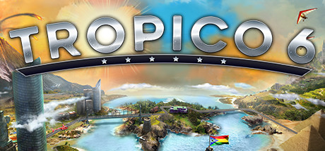](http://store.steampowered.com/app/492720/Tropico_6/)

An example of an outsourcing company that has helped release a game recently is Yippee Entertainment. As they released a mobile Ski Jumping game for IOS and Android for the Winter Olympics 2018. Kalypso Media the publishers of the game are a German mobile game development company known for the on-going game series Tropico and they originally made this game in 2015 for the last Winter Olympics but it was never released so they didn’t want to waste all the work put into the game by never releasing it. However, they were too busy to work on the game with other projects at the time so they outsourced it to Yippee Entertainment who rehashed the graphics, art gameplay and story for the entire game so it was playable and profitable for the release date.

[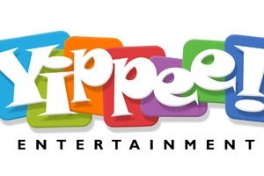](http://www.thelanding.org.uk/community/yippee-entertainment/) [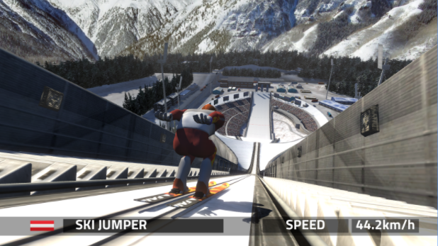](https://play.google.com/store/apps/details?id=com.vividgames.skijumping2012)

### Press and Media

Press and Media are a very important in the gaming industry as they can massively effect how a game is perceived and its success. A games success now is purely based on how it is received by the public and game news channels such as Pretty Good Gaming or Gameranx can change the public’s view to be positive or negative. These gaming news channels will talk about reviews of a game and if they are good or not.

[](https://twitter.com/PrettyBadTweets/status/843387462974169089)[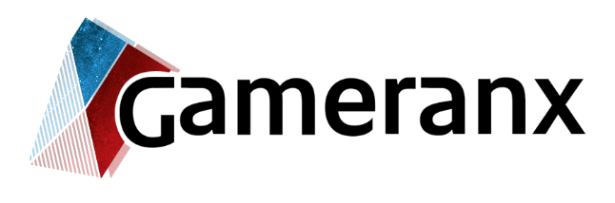](http://deepfreeze.it/outlet.php?o=gameranx)

Gameranx tries to give an unbiased and neutral view to all news they receive and give to their audience. For example, when they give their review on a game they will give the pros and cons of the game but will not try to sway their viewer into buying or skipping a game. Whereas Pretty Good Gaming usually only speaks from their opinion no matter if it is positive or negative and will take a bias to the consumers and say the producers are at fault. They will do this as well in an informal manner by swearing to the company saying it’s ridiculous what they are trying to get away with which brings humour to the dried up and boring market of gaming news channels.

<https://www.youtube.com/channel/UCodK-9eXEm_hWSDDfLr4QzA>

<https://www.youtube.com/user/gameranxTV>

## Resources

<https://www.youtube.com/watch?v=WCuUWGmatpU&index=11&list=PLhyKYa0YJ_5DuIIh7p9FOaR6f-WTTzz_A>

<http://creativeskillset.org/creative_industries/games/job_roles>

# Task 2

## Creative Development

### Game Designer

The game designer is the person who came up with the games idea and has the final say. They will have made the original plan of the story, levels and other elements of the whole process. The designer will work with every team within the development process making sure they are up to task and sticking to the original plan of the game, the developer will listen to ideas that other people have to improve the game.

To be a game designer you do not need any specific qualifications to get into the industry although it would help to have some previous education in 3D games art and design or just a games design course. Although some skills many game developers have are to be able to take constructive feedback, be able to work in a team and make sure your able to sell a game by this I mean explaining the overall concept of your games while still being energetic and not boring, this helps when trying to get a producer for your game.

### Level Editor

The level editor will design the levels and maps of a game while also deciding the location and backdrop the level will have they also decide how hard the level should be, and how much the difficulty will increase throughout the game.

To be a level editor you don’t need any specific training and or qualifications although it is advised that you should have a decent understanding of popular programming languages while also being confident in drawing 3D models/sketches.

A brilliant level designer is Shinya Hiratake known for his contribution to the Mario franchise with Super Mario Galaxy 2, Super Mario 3D World and Land then finally Super Mario Odyssey.

[](http://nintendo.wikia.com/wiki/Shinya_Hiratake)

### Lead Artist

The lead artist will work with the game designer and level editor to decide how the game will look while making up concept art of the games characters to show to the game designer to see if that is the character, they were looking for.

To be a lead artist it is advised that you have a qualification in the field such as a graphics, fine arts or animation degree. While also having a minimum of 5 years’ experience in the industry to work for a major company. Qualities lead artists will usually have been to be able to motivate teams of people and being friendly to establish good working relationships with co-workers.

An example of a well-known lead artist in the gaming industry is Satoru Takizawa.

# Satoru Takizawa

[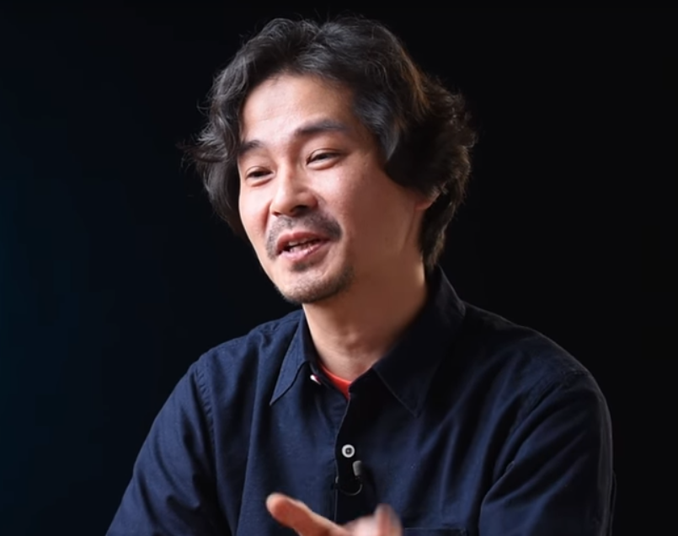](http://nintendo.wikia.com/wiki/Satoru_Takizawa)

## Summary

[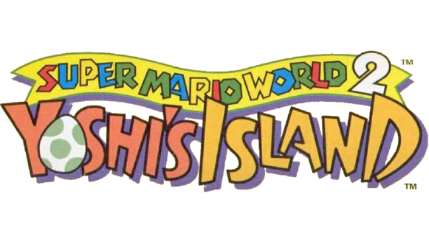](https://www.mariowiki.com/File:SMW2_Yoshi's_Island_Logo.png)Satoru Takizawa is a graphic designer currently working at Nintendo, Satoru was born in Nagano Japan in 1972, he started work at Nintendo around the time when the Nintendo 64 was released However he officially joined Nintendo in 1995. His first project while working with Nintendo was to design the logo for the international version of the SNES (Super Nintendo Entertainment System) video game Super Mario World 2: Yoshi’s Island. That means as soon as Satoru started work at Nintendo, which was when he graduated from Musashino Art University, he was already doing noticeable work. I believe Satoru Takizawa’s greatest achievement up to date is with the critically acclaimed game The Legend of Zelda: Breath of the Wild.

## History at Nintendo

Satoru started his artistic journey when he was a child as he interested in drawing comics rather than playing games on the NES (Nintendo Entertainment System) unlike his childhood friends. The only time he ever got to play games was when he visited his friends’ houses as he himself did not own the system. After every comic made he would pass it around in the household and at school to only hear praise as his family and friends were delighted by how good the comics were.

During college Satoru would work on his friend’s projects and develop CGI effects for them yet he still wasn’t interested in video games until he was introduced to the SNES (Super Nintendo Entertainment System) the upgraded version of the console he used to play at his friend’s house. He firstly played The Legend of Zelda: A Link to the Past and shortly new that he had to work at Nintendo as he saw the possible future videos games had. As you know Satoru achieved his goal of working at Nintendo and he first job was designing the logo for the game Super Mario World 2: Yoshi’s Island. With the release of the Nintendo 64 console Nintendo realised they needed people with a background in 3D design and as Satoru previously worked on 3D designs before, Nintendo turned to him. The company delegated Satoru with designing 3D models for the Super Mario 64 enemies including Klepto the Condor, Unagi the eel and the Manta Ray. [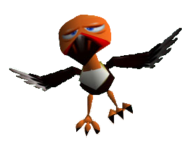](https://s-couting.deviantart.com/)[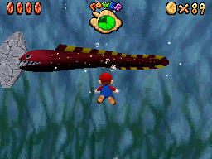](http://mario.wikia.com/wiki/Unagi)[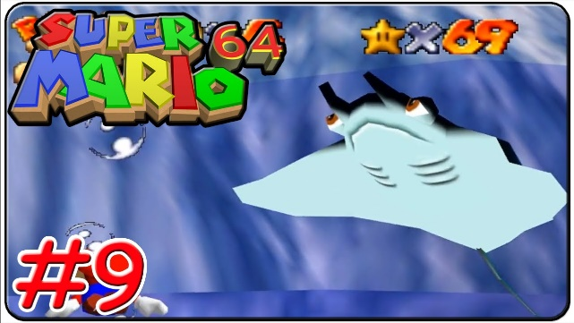](https://www.youtube.com/watch?v=1cha8zy1ahM)

The designs of Klepto the condor and Unagi the eel also made a surprise appearance in the new Mario game Super Mario Odyssey. Klepto the condor can be found in the lost world/ island when he steals Cappy from you and Unagi the eel can be found in Seaside Kingdom as a normal enemy trying to block you path.

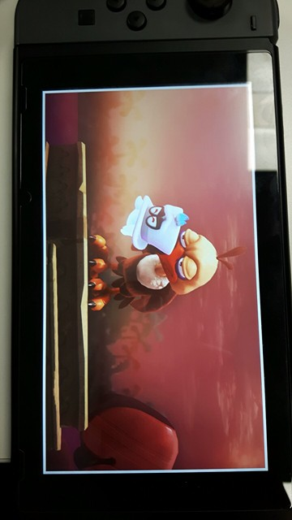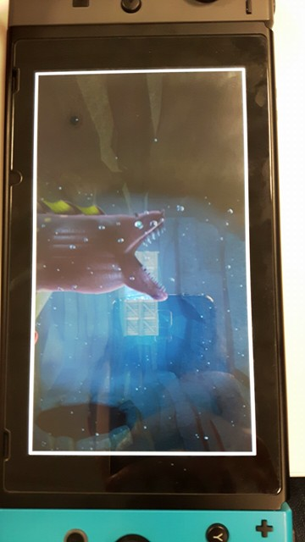

From his work with Super Mario 64 Satoru was assigned the task of creating many bosses and landscapes such as Goras in Titania, Bacoon in Aquas and a couple others. Apparently the software Satoru Takizawa was using while making Star Fox 64 bosses was unheard of in the university he was attending.

Satoru Takizawa’s most important work with the Nintendo 64 console was designing the main antagonist in the game The Legend of Zelda: Orcarina of Time which is Ganondorf. Satoru did so well with the model he even earned Shigeru Miyamoto’s praise who is noted to be the greatest video game designer of all time by IGN. Satoru has contributed to virtually every game in the Zelda franchise with his most recent work as the art director for The Legend of Zelda: Breath of the Wild which is being viewed highly by critics achieving 10 out of 10’s all around.

[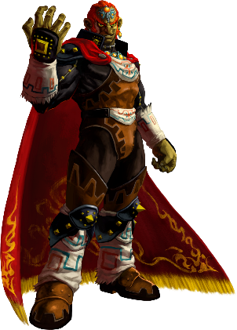](http://zelda.wikia.com/wiki/Ganondorf_(Ocarina_of_Time))

## Art style

Cartoon exaggeration – toon link

[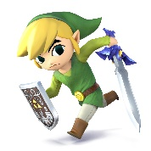](http://www.smashbros.com/us/characters/toon_link.html)When The Legend of Zelda: The Wind Waker was released players were astonished with the completely different design of their beloved hero Link as Toon Link well looks like a cartoon with the bright colours and exaggerated smallness of the revived character also with the big head and eyes on the small body. Many hated but at the same time a lot of people loved the new design of the character and thanked the art department of the game including Satoru Takizawa.

[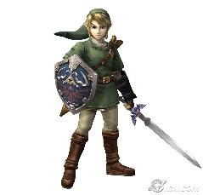](https://comicvine.gamespot.com/forums/battles-7/wind-waker-link-vs-twilight-princess-link-1824948/)However, with the upset of Wind Waker Satoru Takizawa tried a completely different approach with the character Link in the new game The Legend of Zelda: Twilight Princess as he was the art director for the game so he decided to go for a grittier and darker realism for Link and the game to demonstrate the villain Ganon’s horrible reign on the Kingdom known as Hyrule. This new art style is truly shown throughout the design of Link as his tunic is a darker green, his sword is damaged and dark and well everything has changed even Link’s hair colour from a bright blonde to a dirty blonde like it has actual dirt in his hair from battle. But not all of the fan base for Zelda liked this link and though it was too dark.

So, Satoru made a compromise with the new game Legend of Zelda: Breath of the Wild by making Link look like the Twilight Princess Link mixed with the cartoon style of Wind Waker hoping that everyone will like Links new design to fit the fantastic game. Although I don't think Takizawa thought so many people would love the new design for Link and the game to the point that it won Game of the Year for 2017.

[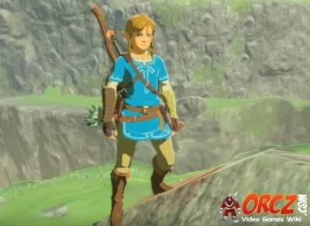](http://orcz.com/Breath_of_the_Wild:_Link)

<https://www.youtube.com/watch?v=cB8mi_Q2NKw>

<http://nintendo.wikia.com/wiki/Satoru_Takizawa>

<http://www.imdb.com/name/nm2242949/>

<https://bulbapedia.bulbagarden.net/wiki/Ken_Sugimori>

<http://pokemon.wikia.com/wiki/Ken_Sugimori>

<https://www.youtube.com/watch?v=5cdX-ekdpJ8>

<http://fuckyeahkensugimori.tumblr.com/>

<https://answers.yahoo.com/question/index?qid=20111013215602AAyumUM>

<https://en.wikipedia.org/wiki/Fanzine>

### Technical Artist

The technical artist will work with the programmers and artists making sure that the game assets will be able to be implemented into the game while also deciding how big the hitboxes will be for the characters and various other things.

To become a technical artist, you will need a degree in some form of art course, although the biggest requirement is to have knowledge and experience of art tools such as Photoshop and 3D modelling software, while also knowing the limitations of certain game hardware.

### Artist

Artists will create concept art and 2D models of the games characters, which will be sent off to the 3D modeller to create the in game design of the character. The artists also do the majority of the colouring and texturing for the in game characters.

Once again to be an artist in the gaming industry you must have a qualification in an art related subject such as graphic design, illustration and fine art. A game artist should also know how to use the relevant software such as Photoshop.

### Animator

The animator’s role in the development stage is to take the 3D model of a game character and animate it so that the character can run around and attack along with various other things.

To be an animator you would need to have an animation related degree, including one for games animation. Other than that you should have done prior work on developing walk and run cycles for in-game characters.

An example of an animator is Ken Sugimori best known for his work with the Pokémon franchise.

# Ken Sugimori

[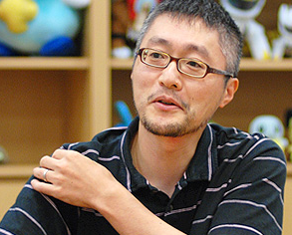](https://bulbapedia.bulbagarden.net/wiki/Ken_Sugimori)

## Summary

Ken Sugimori is a phenomenal illustrator, writer and animator, he is most known for his work with the massive Pokémon franchise. Ken Sugimori was born on the 27th of January 1966 and raised in Tokyo, Japan. Sugimori's first recorded work on a video game was with the SNES (Super Nintendo Entertainment System) title Smart Ball he worked in the animation department and the writing team with the game development company Game Freak. Ken Sugimori acquired his education from Tokyo National College of Technology where of course he studied electronics. [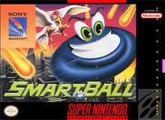](https://en.wikipedia.org/wiki/Smart_Ball)

## History

Sugimori used to illustrate gaming related fanzine's (A magazine in the shape of a fan) called Game Freak from early 1981 to 1986 they contained information on certain characters of a video game and their different moves. Sugimori shortly became friends with the creator of the fanzine Satoshi Tajiri even though he used to only do work on a freelance basis as Ken originally wanted to pursue a career as a manga artist. However, Sugimori's career path changed when he decided officially join Game Freak as an employee. Sugimori and Tajiri decided to change the company and pursue game development in 1989. As a new revived company Tajiri and Sugimori decided to pitch a new arcade game to the famous company Namco and produced Mendel Palace ADD PIC OF GAME. [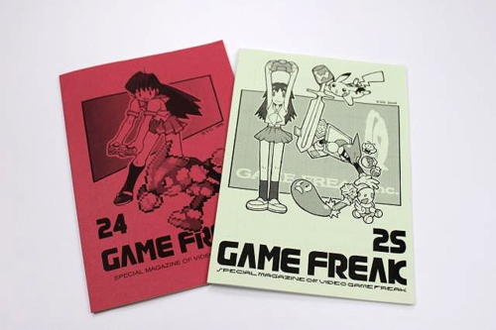](https://warosu.org/vr/?search_tripcode=!!2G3pb9QipZ2&offset=192&task=search2)[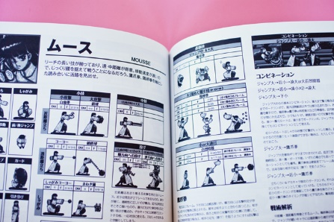](https://www.wired.com/2012/12/japan-gaming-doujin/)[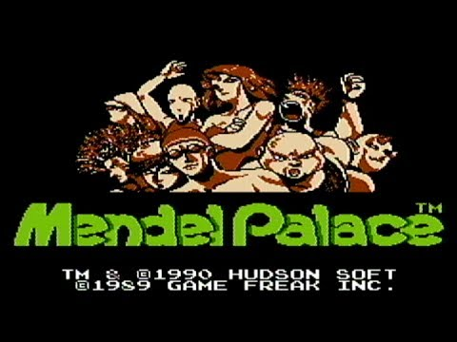](https://www.youtube.com/watch?v=O0xktbPxm8A)[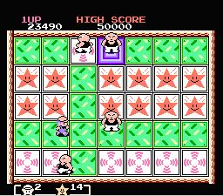](http://www.consoleclassix.com/nes/mendel_palace.html)

Ken Sugimori is mostly famous for creating the final designs for the original 151 Pokémon in Pokémon Red and Green created in 1995 with Atsuko Nishida, Motofumi Fujiwara and Shigeki Morimoto and released in Japan in 1996. Sugimori did the final designs for all of the Pokémon because the company wanted all the Pokémon to have a uniform style. Sugimori based his artwork for the pocket monsters on the in game sprites as this was the only artwork they had for the characters. He has also worked on various Pokémon movies, trading cards, other fantastic games and Sugimori has also works on many manga's. [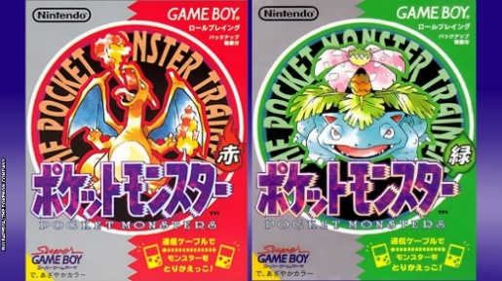](https://northatlanticblog.wordpress.com/2015/10/08/pokemon-lavender-town-syndrome/)

When Game Freak started developing Pokémon Black and White in 2010 Sugimori directed a team of 17 people to design new Pokémon and characters for the game. Sugimori's inspiration for the Pokémon in Black and White from observing animals in zoos and aquariums. Ken Sugimori has also done a few manga's (a Japanese comic) including an original which was a pre-order exclusive in the guide with the game Pokémon Mystery Dungeon: Explorers of Time and Darkness.

[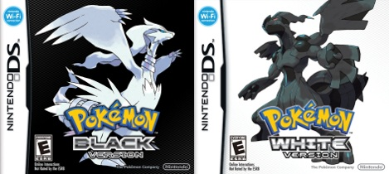](https://pokemondb.net/black-white) [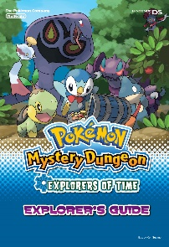](http://www.vgblogger.com/pre-order-alert-pokemon-mystery-dungeon-explorers-of-time-darkness/2714/)

Sugimori has a specific routine when designing new characters for a franchise firstly he will make a rough sketch then he will trace it onto film paper while adding detail, after that he will trace over the paper making a professional character. Often he will change the proportions of the character until he is satisfied with his work.

## Art style

Ken Sugimori's art style is very infrequent and constantly changes depending on what he is working on, such as for the Pokémon game franchise he uses pixel art as that is the only way they could represent art on the outdated Gameboy and or Gameboy colour. His pixelated art is outstanding and this is proven as it captured the heart of millions when playing the original Pokémon games. [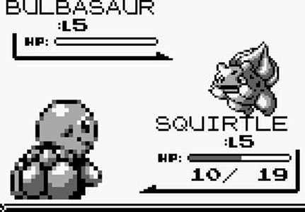](http://gameluster.com/pokemon-red-and-blue-review/) [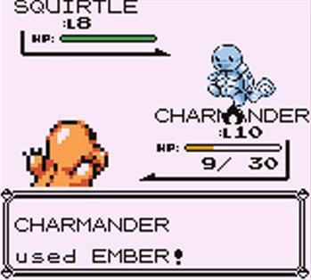](http://mancunion.com/2016/03/14/pokemon-review/)

Ken Sugimori also uses the manga art style as he used to want to be a manga artist before he started designing games but he still incorporates manga into his work now as you can see from the picture of Charizard, Ash and his rival, Sugimori still uses his classic watercolour art style and relates it to Pokémon. Sugimori’s water colour paint art style shines through in his work as it precisely displays his imagination and intended picture he wanted the reader to see.

[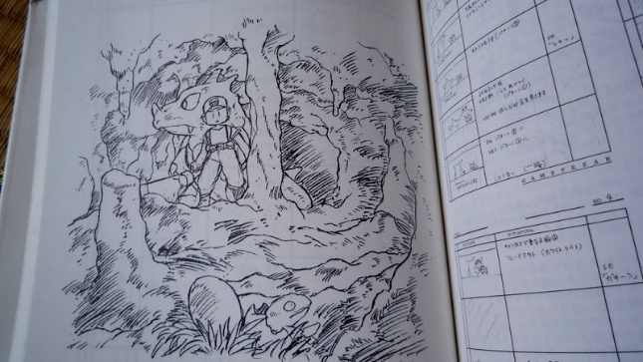](http://www.pepinismo.net/libros-sobre-pokemon/)[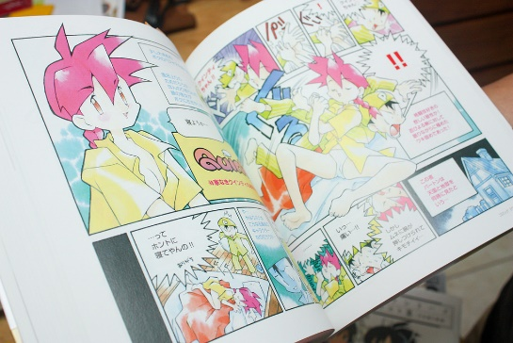](http://pokemon.wikia.com/wiki/File:SugimoriQcover.jpg)[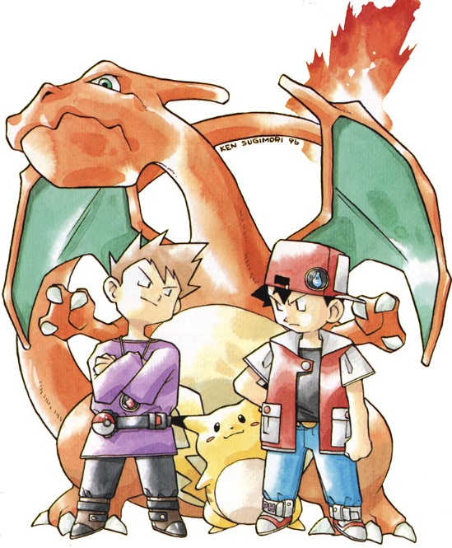](https://www.pinterest.com/pin/236579786645693277/)

With Pokémon as a franchise becoming so popular an anime was created which was called Pokémon Indigo League and in the animation department for this show was the Ken Sugimori and that is clearly seen in the art style for the show as it looks just like Sugimori’s old water colour manga’s just without the water colour and with bold thick paint colours. This is shown truly with the character Misty in the television show compared to a female character in one of Sugimori’s manga’s they look almost exactly alike with the same straight lines representing their chins.

[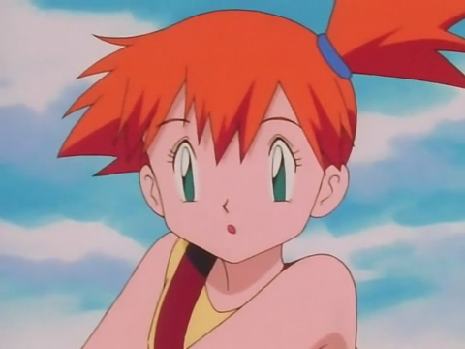](http://www.j-opolis.net/sections/television/ashmisty_3.html)[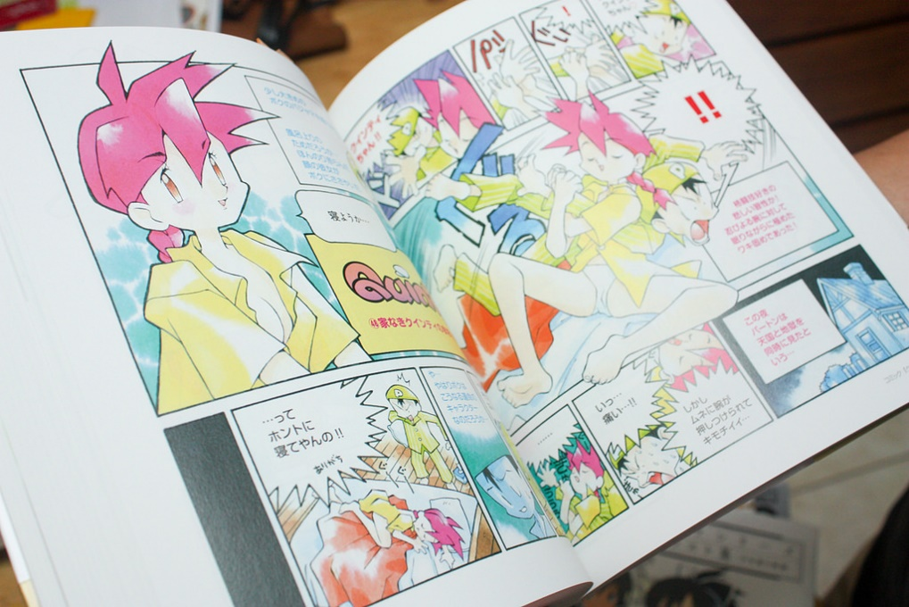](http://pokemon.wikia.com/wiki/File:SugimoriQcover.jpg)

<https://www.youtube.com/watch?v=cB8mi_Q2NKw>

<http://www.imdb.com/name/nm2242949/>

<https://bulbapedia.bulbagarden.net/wiki/Ken_Sugimori>

<http://pokemon.wikia.com/wiki/Ken_Sugimori>

<https://www.youtube.com/watch?v=5cdX-ekdpJ8>

<http://fuckyeahkensugimori.tumblr.com/>

<https://answers.yahoo.com/question/index?qid=20111013215602AAyumUM>

<https://en.wikipedia.org/wiki/Fanzine>

### Audio Engineer

The audio engineer will produce all the sound effects and music for a game that fit the artistic style of the game and its genre. They would also have to be the right length for example in a Mario game the song would usually have to be the time of an average play through of the games level. Also if the song is repeated for example the title screen or healing station of a game they will to make it catchy and not obnoxious like the Pokémon centre in the Pokémon game series.

To be an audio engineer you don’t need any specific qualification but it is advised that you do have education in subject music related, you should also be able to compose music and play a couple instruments yourself. Also, you should know how to use music editing software as you will be using that on the job.

## Technical Development

### Game Programmer

Game Developers, like in the name develop games or at least the programming part of the game. Game developers have to be great at problem solving, as that is a big part of their job: finding and solving bugs. Developers have to think analytically and know how to efficiently fix bugs and various other issues. They also have to stay up to date on different techniques and programming languages.

To be a game programmer in the industry you should have a degree in physics, maths or computer science. Having a GCSE in computer science will help to, other than that you should know relevant software development techniques while also having knowledge in the programming language C++.

### Lead Game Programmer

The lead game programmer will be concluding the final checks of a level making sure the coding is done to right standard and is concise so it doesn’t take up too much memory. Also making sure that the level works with minimal bugs. Another role of the lead programmer is to motivate the programming team and make sure they are staying up to schedule and if not they will discuss it with the team and if it is out of there control they will ask the boss if they could have an extension.

To be a lead programmer you should have all the skills and qualifications you would need to be game programmer while also being able to lead a team and motivate people.

An example of a senior programmer Gary Lightfoot who works at Radiant Worlds, Gary Lightfoot is known for helping develop the game SkySaga: Infinite Isles which is an online voxel based MMO which looks like Minecraft and Cubeworld combined. As the game is run online Gary has to make sure that the game while running code for every player in the game does not crash.

[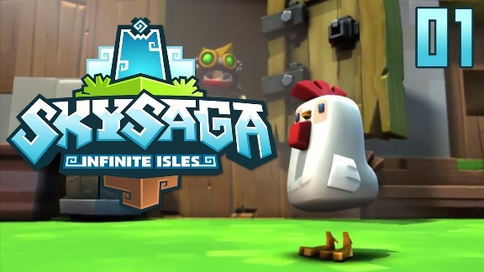](https://www.youtube.com/watch?v=IaOKVvw9_ks)[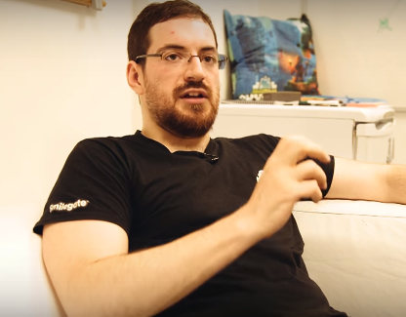](http://creativeskillset.org/creative_industries/games/job_roles/333_lead_programmer_games)

## Project Implementation

### Project Manager/Producer

The producers job is to ensure that the game is being produced; to a high quality, in budget, within the time scale given and maintains the original vision of the game. The producers are usually in charge of the finance for the game making sure the development process stays in budget while also trying to find ways to cut costs.

For this job you don’t need any specific qualifications, the main thing employers will be looking for is your prior experience in managing teams and the enthusiasm you have for the gaming industry.

### Assistant Producer

The assistant producer performs many tasks throughout the development process one of them is handling the communication with the developers and publishers. The assistant producers also ensure that all of the teams in the development process are producing high quality work within the time scale given.

For the job of assistant producer, you don’t need any specific qualifications as well as any experience as you will get most of it from the job as it is a junior role. However, you will need to show the enthusiasm you have towards games in the interview.

### External Producer

The external producer will work outside the head office maybe in another country where the game is being sold. They will oversee the publisher’s sales and the marketing department for the game.

While you don’t need a specific qualification to be an external producer it would help to have a qualification in the general area of study of visual and technical arts. Experience in the game development process will be needed.

### Creative Director

The creative director oversees any changes made to the game for example if the character changed from male to female the creative director will have to agree with the change before it is implemented.

To be a creative director you don’t need any specific qualifications although experience in the game development process is a must.

## Quality Assurance

### QA Tester

A QA tester is someone who will play a game before it’s released purposely looking for bugs/glitches in the game, they will then write on a document the threat level of the bug for example if it is just a small graphical glitch or if it’s game breaking, then how the bug was caused if it is repeatable. The Game Developers will then fix the bug to be implemented into the new version. The QA tester will keep replaying new versions of the game until the game is playable with few bugs.

To be a QA tester you don’t need any specific qualifications, you just have to know a little bit of programming knowledge so you know what caused a bug/glitch in a game. As well as being an avid gamer to have that gaming knowledge to help you succeed quickly in games, know what a bug is and have fun while playing so you don’t get bored and unmotivated to do your work.

An example of a QA tester is myself as I currently have a job where I test games and from this job I have learnt how to be; perseverant in order to continue playing after hitting a major bug that sets you back really far in a game, patient as you will need it to keep playing over the same levels and tutorials after every new build off a game, perceptive so I can spot out bugs efficiently.

## Business Development

### Public Relations Manager

The public relations manager will make sure the game is received well to the public while also keeping the workers from releasing any information about the game without the manager’s consent and behaving well.

An example of a public relations manager is Stuart Duncan; he is an autistic farther that made a Minecraft server for his autistic son. Stuart made this server to be a safe haven where people can feel safe and bullying was not tolerated anyone who did such would be immediately band from the server.

<https://www.facebook.com/autismfather/>

### Product Manager

The product manager’s role is to think up of financial campaigns and go through with them for the game to increase the sales and awareness of it. They will work with the marketing team to organise global campaigns for example Nintendo deciding when to release a game in America or Europe.

To be a product manager you don’t need any specific qualifications just general knowledge of the life cycle of a game through the development stage. Management experience would help along with enthusiasm for the gaming industry for the job.

## Resources

<http://creativeskillset.org/creative_industries/games/job_roles>